Credit Card Approval Prediction
A machine learning based web application for automating credit card approval decisions
Project Documentation
Submitted by
Allukuri Tulasiram (Team Lead)
email id: allikuritulasiram@gmail.com
Kamarajugadda Badrinath Sai
email id: badrikamarajugadda6@gmail.com
Bandaru Madhavi
email id: madhavibandaru0207@gmail.com
Team id: SWTID-2026-4073

Project Description
Credit Card Approval Prediction is a machine learning based web application built to automate one of the more repetitive and error-prone parts of a bank's workflow: deciding whether a credit card application should be approved. Instead of a credit analyst manually going through an applicant's income, credit score, employment history, and existing debt every single time, the system takes that same information and returns a prediction in under a couple of seconds, along with a confidence score.
Under the hood, three different classification models — Logistic Regression, Random Forest, and XGBoost — are trained on applicant data and compared against each other on accuracy, precision, recall, F1-score, and ROC-AUC. Whichever model performs best is the one users are shown by default, though the dashboard lets you switch between all three and compare their predictions side by side. The whole thing is wrapped in a Flask web application with a simple, clean interface, so it doesn't take a data science background to use it.
The goal isn't just to build a model that works in a notebook — it's to package that model into something a bank employee (or even an applicant, for a quick eligibility check) could actually open in a browser and use.

Application Scenarios / Use Cases

Scenario 1: Automated Application Screening
A credit analyst enters a new applicant's financial profile — income, employment status, existing debt, credit score, and so on — into the web form. The model returns an instant Approved or Denied prediction with a confidence percentage, letting the analyst prioritize which applications need a closer manual look and which can be fast-tracked.

Scenario 2: Applicant Self-Check
Before formally applying, a prospective applicant can use the same tool to get a rough sense of their approval odds. This sets more realistic expectations and can reduce the number of applications that were unlikely to be approved in the first place.

Scenario 3: Model Performance Review
A data science or risk management team uses the Model Comparison and Feature Importance pages to understand how each model is performing and which factors are driving approval decisions the most — useful both for auditing the system and for explaining decisions to regulators or customers.

Technical Architecture Overview
The system follows a fairly standard three-layer structure: a frontend that collects input and displays results, a backend that handles preprocessing and prediction, and a storage layer holding the trained models and dataset.
- Frontend: HTML and CSS templates rendered through Flask's Jinja templating engine, covering the Overview, Model Comparison, Feature Importance, and Live Prediction pages.
- Backend: A Flask application (app.py) that receives form submissions, validates the input, and routes it through the preprocessing pipeline before handing it to the selected model.
- Preprocessing layer: Encodes categorical fields (like employment status and education) and scales numeric fields (like income and credit score) using the same preprocessor that was fitted during training, so predictions stay consistent with how the model was trained.
- Model layer: Three trained models — Logistic Regression, Random Forest, and XGBoost — saved as serialized files and loaded into memory when the app starts, so predictions don't require retraining on every request.
- Deployment layer: The application is deployed on Vercel, giving it a public URL that doesn't require any local setup to access.
When a user submits the prediction form, the request goes: browser → Flask route → preprocessing → model inference → response back to the browser, all within about a second under normal load.

Prerequisites
- Python 3.9 or later installed on your machine
- pip (Python's package manager)
- A code editor such as VS Code
- A modern web browser (Chrome, Firefox, or Edge)
- Git, if you plan to clone the repository or push changes to GitHub
- (Optional) A Vercel account, if you want to deploy your own copy

Prior Knowledge Required
- Basic Python programming (functions, data types, working with libraries)
- A general understanding of machine learning concepts — what training and testing a model means, what accuracy/precision/recall represent
- Basic familiarity with pandas and scikit-learn is helpful but not mandatory
- A basic understanding of how a web form sends data to a server (HTML forms, HTTP requests) is useful for following the Flask code
- No prior experience with Flask specifically is required — the framework is simple enough to pick up from the code itself

Project Objectives
- Build a machine learning model that can predict credit card approval outcomes from applicant data with reasonable accuracy
- Compare multiple algorithms rather than relying on a single model, to identify which approach genuinely performs best on this data
- Wrap the model in a usable web interface so the prediction isn't locked away in a notebook
- Make the system's decisions at least partially explainable, through feature importance visualization
- Deploy the finished application so it can be accessed and demonstrated without local setup

System Workflow
- The applicant (or analyst) opens the Live Prediction page and fills in the required fields: age, gender, education, marital status, employment status, years employed, annual income, existing debt, number of existing credit cards, number of dependents, credit score, and property ownership.
- On clicking "Predict Approval", the form data is sent to the Flask backend.
- The backend validates the input, then passes it through the preprocessing pipeline — categorical fields are encoded and numeric fields are scaled using the same logic applied during training.
- The preprocessed data is fed into the selected model (Logistic Regression, Random Forest, or XGBoost).
- The model returns a prediction (Approved or Denied) along with a probability score.
- The result is sent back to the browser and displayed instantly, along with a gauge chart showing the approval probability and a short explanation (such as the debt-to-income ratio).

Milestone 1: Requirement Analysis & System Design
This phase focused on understanding the actual problem before writing any code. The team identified that manual credit review is slow and inconsistent, and mapped out what a data-driven alternative would need to look like — both from the bank's side (faster, more consistent decisions) and the applicant's side (transparency into why a decision was made).
Key deliverables from this phase included problem statements from both perspectives, a customer journey map tracing the applicant's experience from application to decision, functional and non-functional requirements, and an initial solution architecture sketching out how data would flow from the web form through to a prediction.

Milestone 2: Environment Setup & Initial Configuration
With the design settled, the next step was getting a working development environment in place. This meant installing Python and the required libraries (Flask, pandas, NumPy, scikit-learn, XGBoost, joblib), setting up the project folder structure, and getting the applicant dataset ready for use.
- Installed Python 3.9+ and set up a virtual environment
- Installed core dependencies via pip install -r requirements.txt
- Organized the project into clear folders: app/, src/, models/, data/, and templates/
- Loaded and inspected the applicant dataset to understand its structure before building the preprocessing pipeline

Milestone 3: Core System Development
This was the bulk of the actual build. Data preprocessing and feature engineering came first — cleaning the dataset, encoding categorical fields, and scaling numeric ones. From there, the three models were trained and evaluated against each other, with the best-performing one (by ROC-AUC) selected as the default.
On the application side, the core Flask app was built out with routes for the prediction endpoint and the dashboard pages, along with the HTML templates and styling needed to make the interface usable rather than just functional.

Milestone 4: Integration & Optimization
With the model and the web app both working independently, this phase connected them together — loading the trained model and preprocessor into the Flask app at startup, and making sure predictions made through the web form matched what the model produced during evaluation.
Optimization work at this stage included trimming unused dependencies to keep the deployment lightweight, making sure prediction response times stayed well under two seconds, and cleaning up the dashboard pages (Overview, Model Comparison, and Feature Importance) so they loaded quickly even with the full dataset.

Milestone 5: Testing & Validation
Before considering the project complete, the team ran through a set of functional and performance test cases — checking form validation, verifying that predictions matched expectations for both clearly approvable and clearly risky applicant profiles, and confirming that model switching worked correctly.
Test Case | What Was Tested | Result
High credit score applicant (850) | Prediction for a low-risk profile | Approved, 92.4% confidence
Low credit score applicant (501) | Prediction for a high-risk profile | Denied, 71.6% confidence
Borderline applicant (credit score 720) | Prediction near the decision boundary | Approved, 51.7% confidence
Response time | Time taken to generate a prediction | Under 2 seconds on average
Model switching | Predictions across all three models | All three models responded correctly

Deployment
The application is deployed on Vercel, giving it a public demo link that can be accessed from any browser without local setup. Deployment involved configuring the Flask app's entry point, trimming the dependency list to keep the deployment size manageable, and verifying that the live version behaved identically to the local one.
Below are screenshots of the deployed application in use — a denied prediction for a low credit score applicant, and two approved predictions for stronger applicant profiles.
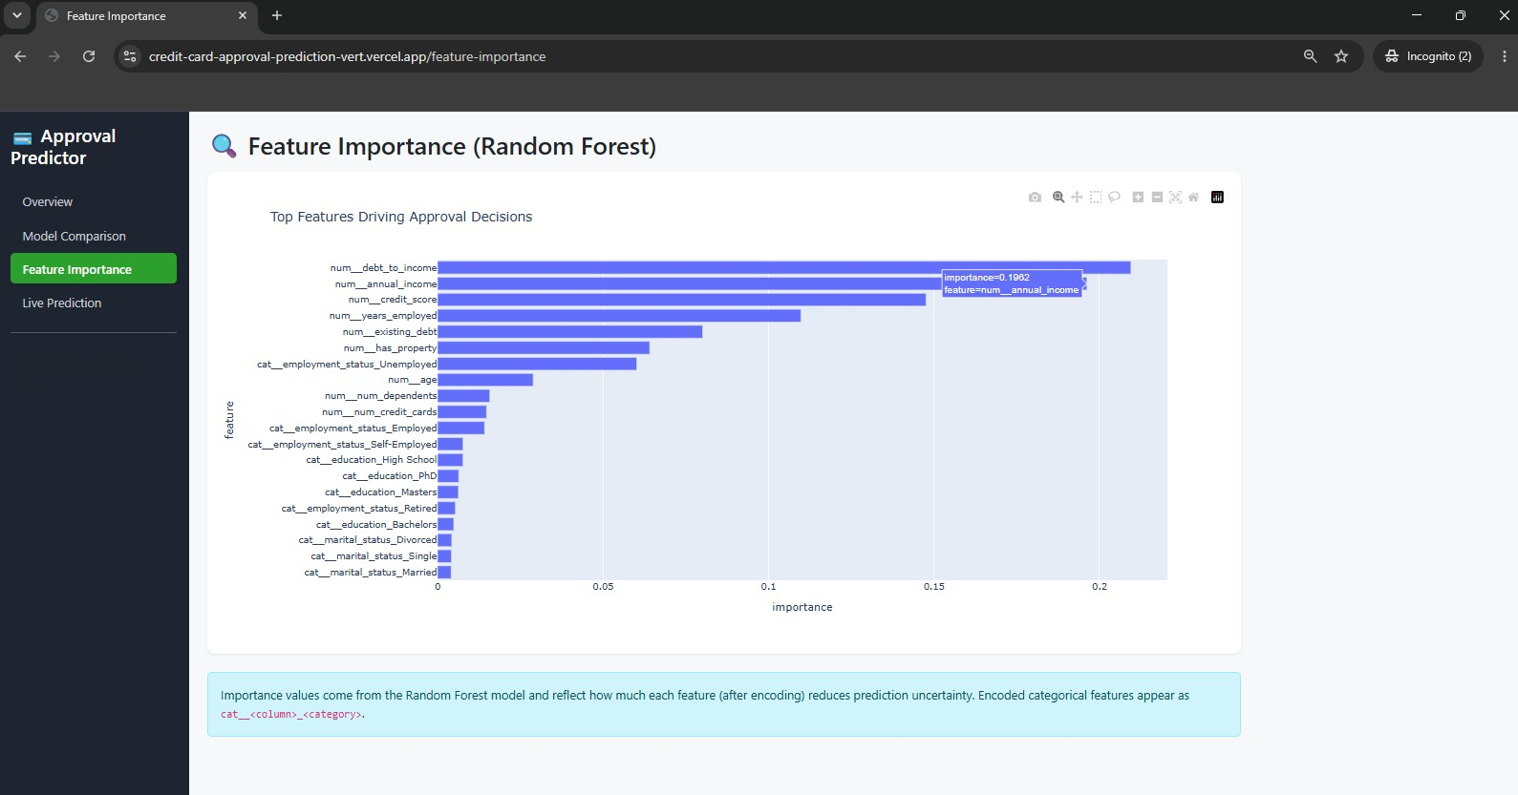
Live Prediction — a low credit score applicant is denied, with a 28.4% approval probability.
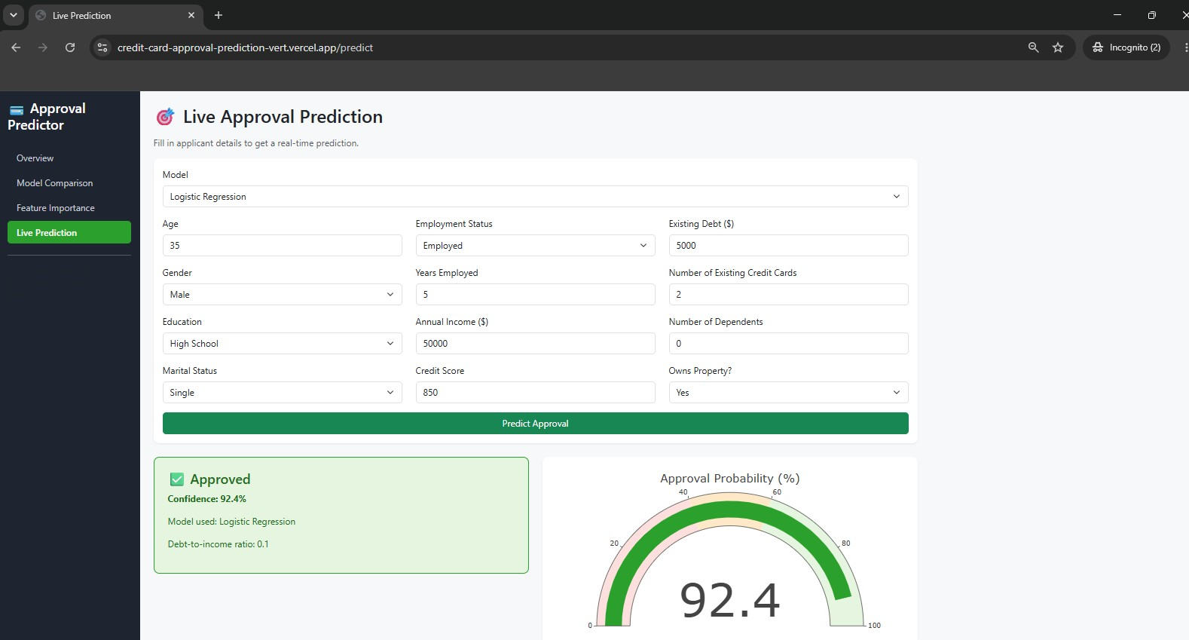
Live Prediction — a strong applicant profile is approved with 92.4% confidence.
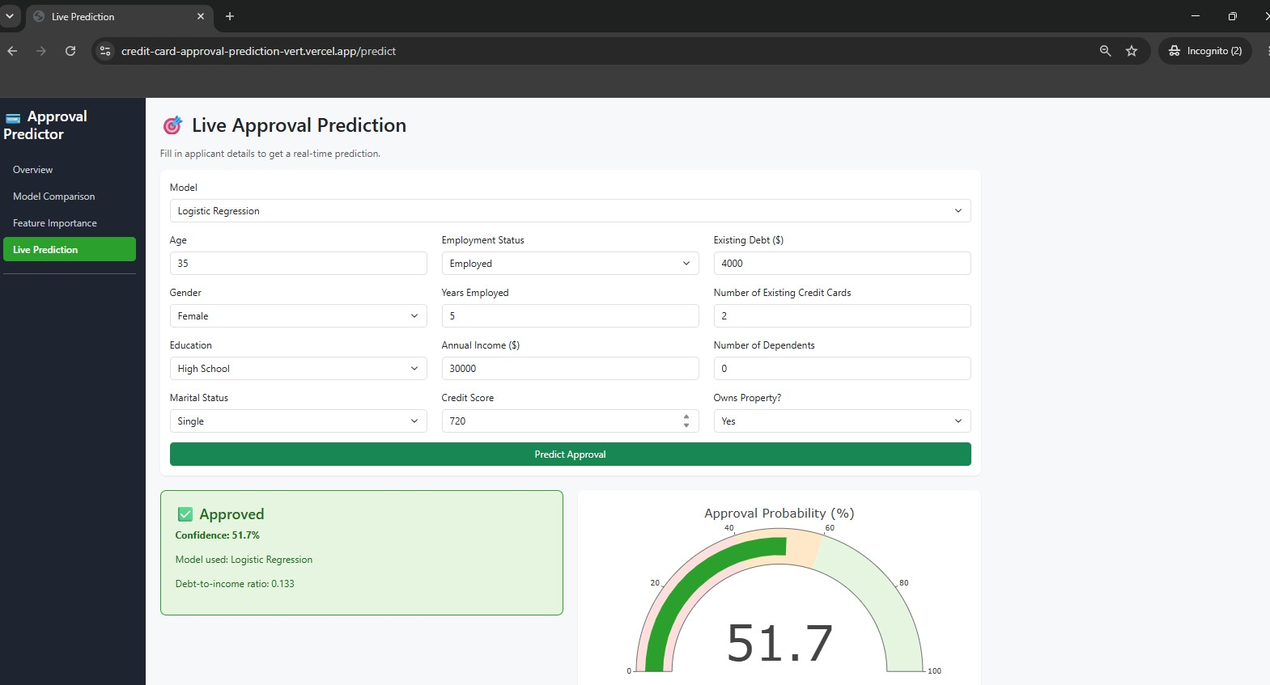
Live Prediction — a moderate applicant profile is approved with 81.5% confidence.

Project Structure
The repository is organized to keep data, model logic, and the web application clearly separated, so any one part can be updated without touching the others.

credit_card_approval/

├── data_generator.py # Generates the synthetic dataset

├── train_models.py # Trains & evaluates 3 ML models

├── app.py # Streamlit dashboard (optional)

├── flask_app.py # Flask dashboard (no Streamlit needed)

├── templates/ # HTML templates for the Flask app

│ ├── base.html

│ ├── overview.html

│ ├── model_comparison.html

│ ├── feature_importance.html

│ └── predict.html

├── static/

│ └── style.css

├── requirements.txt

├── data/

│ └── credit_card_data.csv

└── models/

├── logistic_regression.joblib

├── random_forest.joblib

├── xgboost.joblib

└── metrics.json

Results
Across the three models trained, all performed within a close range of each other, with ROC-AUC scores between 0.90 and 0.91 — a solid result for this kind of tabular classification problem.
Model | Accuracy | Precision | Recall | F1 | ROC-AUC
Logistic Regression | 0.832 | 0.786 | 0.757 | 0.771 | 0.914
Random Forest | 0.832 | 0.798 | 0.738 | 0.767 | 0.905
XGBoost | 0.827 | 0.782 | 0.746 | 0.763 | 0.906

Debt-to-income ratio, annual income, and credit score consistently came out as the strongest predictors of approval across the models — which lines up with what you'd expect a human credit analyst to weigh most heavily too.
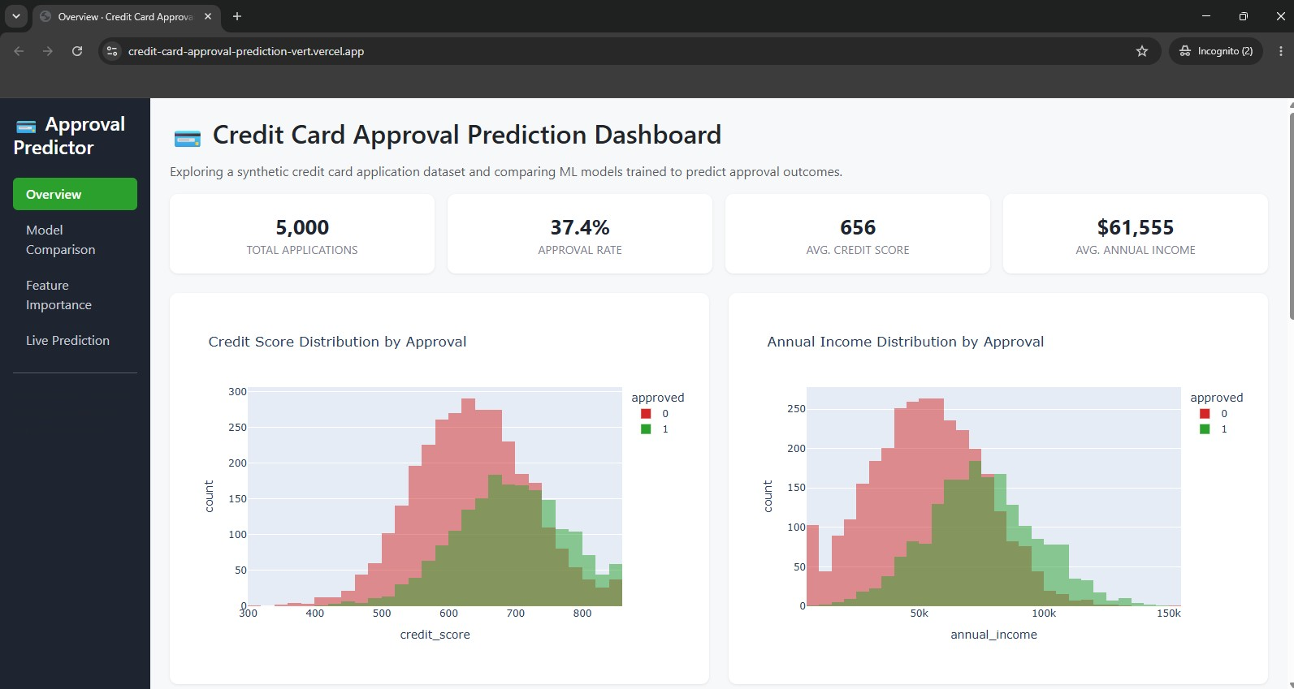
Dashboard overview — dataset size, overall approval rate, and credit score distribution by outcome.
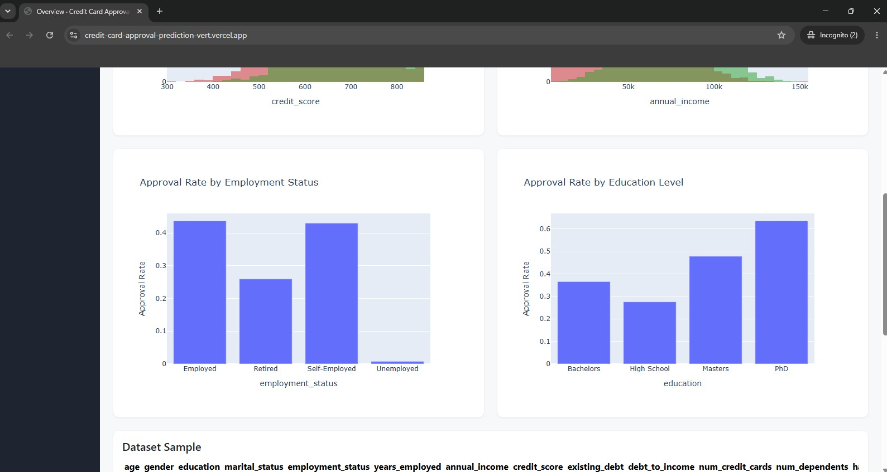
Approval rate broken down by employment status and education level.
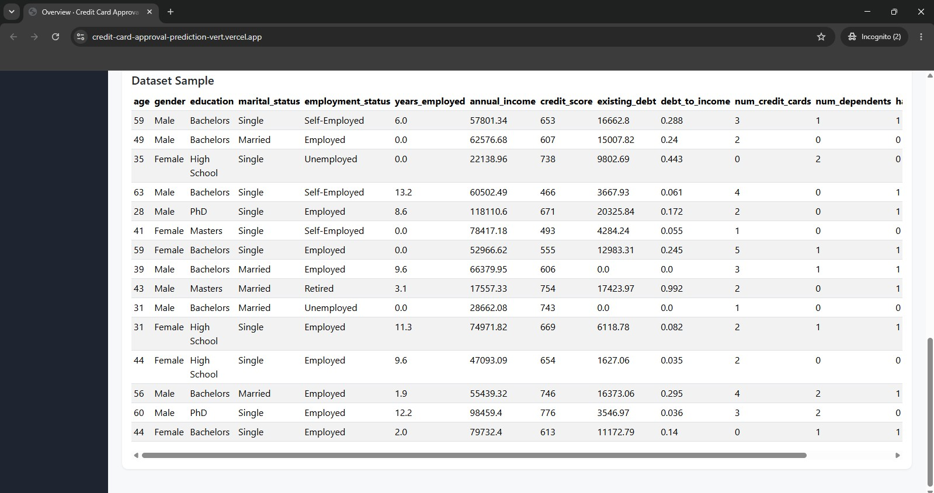
Side-by-side comparison of accuracy, precision, recall, F1, and ROC-AUC across all three models.
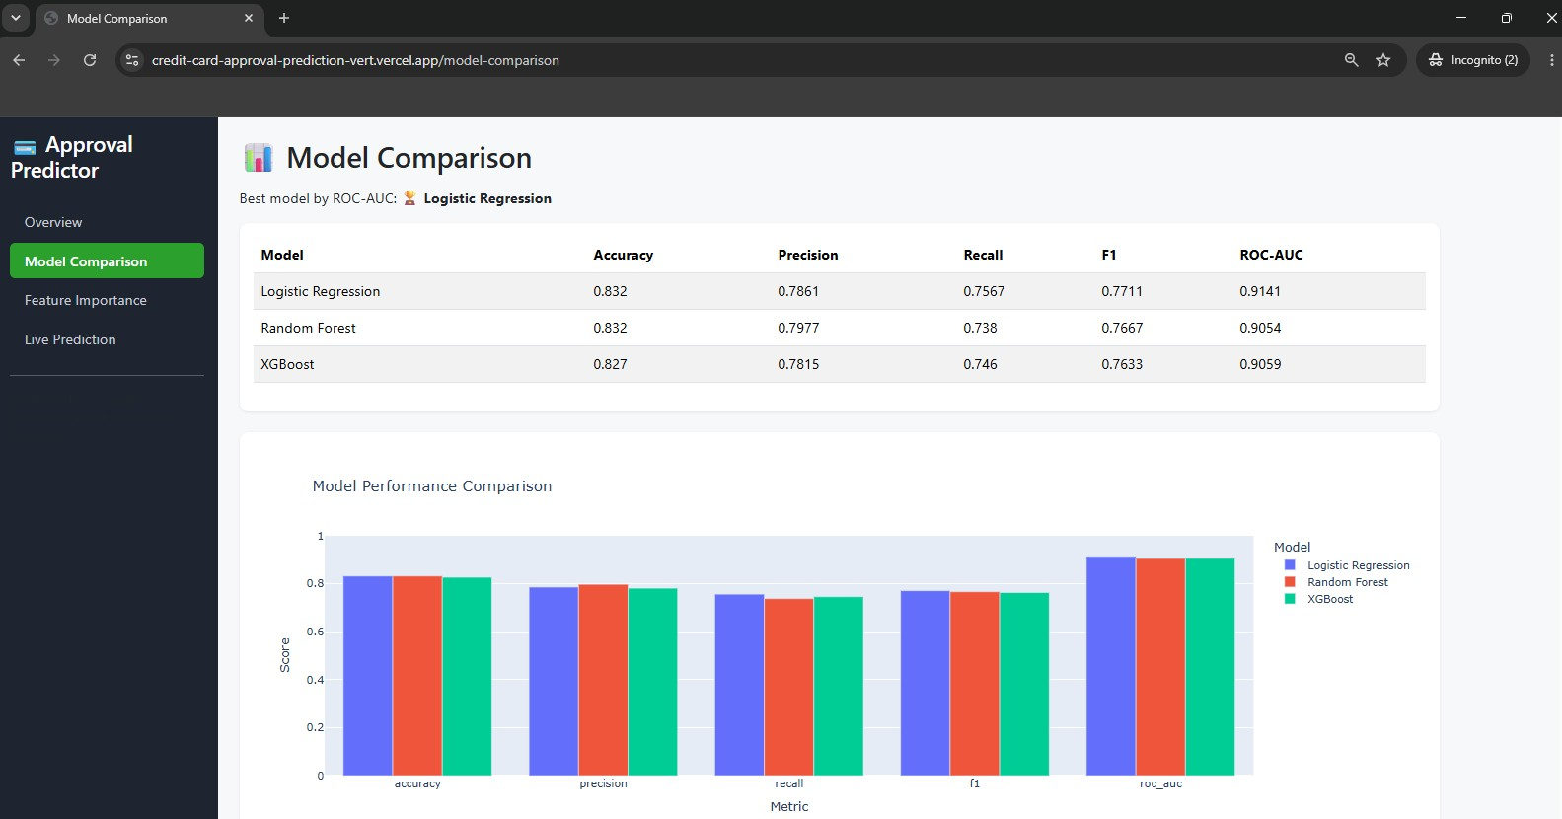
Confusion matrices for Logistic Regression, Random Forest, and XGBoost.
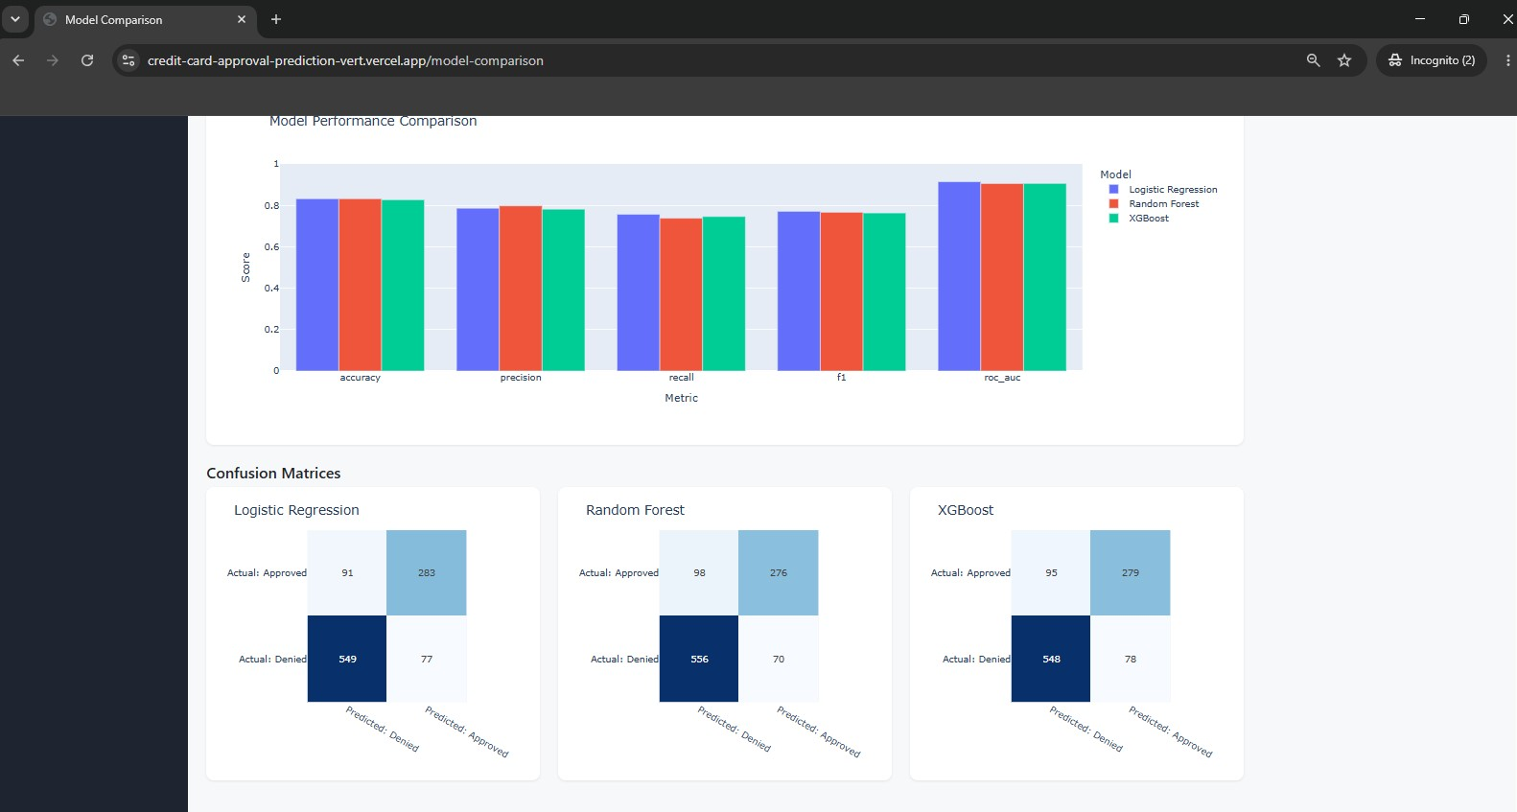
Feature importance ranking from the Random Forest model.

Advantages & Limitations

Advantages
- Delivers predictions in under two seconds, compared to manual review that can take hours or days
- Removes reviewer-to-reviewer inconsistency by applying the same model logic to every application
- Offers transparency through feature importance, rather than acting as a pure black box
- Lets users compare multiple models instead of trusting a single algorithm blindly
- Runs as a lightweight web app, requiring no specialized software on the user's end

Limitations
- Trained on a fixed historical dataset, so it won't automatically account for shifts in economic conditions or lending policy over time
- Does not yet integrate with live banking systems or real-time credit bureau data
- Explainability is limited to overall feature importance rather than a per-prediction breakdown
- Currently supports one prediction at a time, with no batch upload option

Future Enhancements
- Train on larger, real-world datasets (with proper anonymization) to improve real-world reliability
- Add SHAP-based explainability so each individual prediction can be broken down feature by feature
- Support batch predictions through CSV upload for reviewing many applications at once
- Add user authentication so analysts can log in and review prediction history
- Expose the model through a standalone API (for example via IBM Watson Machine Learning) so it can plug into other banking systems
- Set up periodic retraining so the model stays accurate as application patterns shift over time

Conclusion
This project set out to answer a fairly practical question: could a machine learning model make credit card approval decisions faster and more consistently than a manual review process, without sacrificing accuracy? Based on the results — ROC-AUC scores above 0.90 across all three models tested, and prediction times under two seconds — the answer looks like a solid yes, at least for the scope this project covers.
Beyond the model itself, building this as a full web application rather than just a notebook was an important part of the project. It forced decisions around usability, response time, and explainability that a notebook alone wouldn't have surfaced. There's still real room to grow — particularly around explainability at the individual prediction level and integration with live data sources — but the current system stands as a working, deployable proof of concept for how banks could speed up and standardize an otherwise slow, manual process.

